******Chapter 11**

**Employment****Communication**

**WRITE TO LEARN**

Place yourself in the future, ten years from now. Write a one-page description of your life. Where do you live? What talents and interests have you pursued? What kind of job do you have? Are you happy with your job? How much money do you make? How did you create this life? In other words, how did you get here?



*Focus on Employment Communication*

Read the sample resume on the next page and answer these questions:

1. Glance at the resume for ten seconds and then look away. What do you remember? In other words, what stands out?
2. Does the resume look balanced and attractive? Explain.
3. What information is included in each major section?
4. How does Matt’s work experience relate to his job objective?
5. What impression does his earning some of his college expenses make? What kind of impression does his volunteer work make?

*What If?*

1. Matt had 15 years experience in the computer industry? 10 years in the restaurant business? 5 years of military experience?
2. Matt had won an academic scholarship or an award for web design?
3. Matt were applying for a faculty position or a graphic arts position?

**248** | Chapter 11



**Matt R. Abboud**

mabboud@comm.mcc.edu

*Temporary* *Permanent*

67B Whistle Run Apartments 803 Princeton Road

Albuquerque, New Mexico 87103-4737 Albuquerque, New Mexico 87118-1190

505.555.0173 505.555.0149

**OBJECTIVE**

**QUALIFICATIONS**

Computer programmer in an industrial environment

1. 3 years’ experience in networking and computer support
2. AAS degree in Computer Programming
3. Experience in C ++, Microsoft SQL Server, Visual Basic 2008, and Windows Server 2008
4. Proficient in all Microsoft Office (2000/XP) products

|  |  |  |  |
| --- | --- | --- | --- |
| **EDUCATION** | Maddox Community College, Albuquerque, New Mexico | | |
|  | AAS, anticipated graduation May 2010 | |  |
|  | Major: Computer Programming, GPA 3.9/4.0 | |  |
|  | *Major Courses* |  |  |
|  | Advanced C++ | Visual Basic 2008 | Internet Programming |
|  | Java Programming | Database Concepts | Systems Analysis/Design |
|  | UNIX Fundamentals | Database Management | International Business |
|  | Windows Server | Interpersonal | Technical Writing |
|  | Admin | Communication |  |
| **CO-OP** | **Wadell Computer Industries** | | **January 2010–Present** |
| **EXPERIENCE** | Albuquerque, New Mexico | |  |

1. Design and develop test specifications for software systems
2. Evaluate existing computerized systems to improve efficiency
3. Serve on Quality Assurance Team in IT department

**Landcaster Microsystems** **July 2009–December 2009**

Santa Fe, New Mexico

1. Set up and maintained clients using Windows NT/Server 2008
2. Maintained SQL server database
3. Answered help desk calls

|  |  |  |
| --- | --- | --- |
| **OTHER** | **Earned half of college expenses working part-time** | **2005–2009** |
| **EXPERIENCE** | Auto Express, Santa Fe, New Mexico, Salesclerk |  |
|  | AG Shirt Factory, Santa Fe, New Mexico, Production Line Worker |  |
| **VOLUNTEER** | Special Olympics—Santa Fe, New Mexico | **2007** |
| **WORK** | Big Brothers Big Sisters—Santa Fe, New Mexico | **2006–2008** |

**Sample Resume**

Employment Communication **| 249**

****Writing@Work

|  |
| --- |
| Courtesy of Kate Houck |

Kate Houck manages the Implementation Team for Employment Law Training,

a San Francisco–based company that provides employers with online

compliance training. In addition to a BA in political science, she has extensive experience evaluating job applicants, interviewing, and hiring employees for companies ranging from Internet startups to Fortune 500s.

“The biggest challenge in reviewing a stack of resumes is culling the wheat from the chaff,” explains Kate. “I look for a resume that has a good layout and concise, engaging statements about relevant experience and accomplishments. It should also demonstrate passion for or expertise in something. You can usually teach someone to do a job, but it is harder to teach someone to be an employee who cares.”

The most glaring mistakes to avoid in a resume or cover letter are the easiest ones to prevent. Kate emphasizes that these documents “should have no typos or spelling errors. If you mess this up, you are just being careless.” She also recommends that job candidates google themselves to eliminate undesirable public listings: “It may not be fair, but your online presence serves as a sort of reference in today’s electronic age. So if there is anything posted that you don’t want an employer to see, make sure it is under a pseudonym or restricted access; otherwise, it’s fair game.”

Having seen so many resumes has taught Kate precisely what makes a great resume and how to make her own resume float to the top of the pile: “The top two things I try to convey in my resume are competence and excellence. I not only highlight what I have done at each job, but also provide evidence that shows how I surpassed the objectives for that position. I don’t want to be just a performer on my resume or at work; I want to be a star.”```````````````11`

**Think Critically**

1. Does your resume meet Kate’s standards for “good layout and concise, engaging statements about relevant experience and accomplishments”? Why or why not?
2. Would Kate see that you have “passion for or expertise in something?” How can you change your resume so that someone like Kate puts it at the top of the stack?

Printed with permission of Kate Houck

**250 |** Chapter 11

**GETTING STARTED ON EMPLOYMENT****COMMUNICATION**



The job you seek may be a long-awaited dream job or a part-time job to help you through school. Whatever the job, you will need attractive and well-crafted employment communication to highlight your strengths for the job market. You will use your technical writing skills to analyze your audience’s needs and then persuade your audience that you can fulfill those needs.



Employment communication includes a **resume** (a one- or two-page summary of your qualifications), a **cover letter** (to accompany the resume), a **follow-up letter** (to thank the employer for the interview and to summarize your qualifications), and possibly a **resignation letter** (to announce your intention to resign). Resumes and the accompanying letters are important because they:



Create a professional, favorable impression.

Allow you to control the presentation of your skills on paper. Encourage an employer to call you to arrange an interview.

Give employers something to look at before you fill out any applications they may require.

Maintain goodwill between you and your employer.

To get started on employment communication, assess your strengths, learn what you can about a prospective employer, and choose your references. Then consider the employer’s perspective and expectations.

**Assess Your Strengths**

Good employment communication begins with self-assessment. Consider your skills, aptitudes, education, interests, and experience. Use the following questions to help you determine your strengths as an employee:

**Education:** What is your grade point average (GPA)? What special classeshave prepared you for a particular job? What degrees do you hold? Where did you go to school, and when did you graduate?

**Employment:** What jobs have you held? Write the job title, city and state,and dates for each job you now have or have previously held. Describe your duties and special projects on the job. Be specific.

**Accomplishments:** List your accomplishments (scholastic, job-related,extracurricular, or community) over the last several years. Include any honors or awards you received. What skills do these accomplishments and honors illustrate? Would these skills be useful in the workplace?

**Skills:** What are your special talents? What can you do well? Are you agood problem solver, creative thinker, good communicator? Do you have special skill sets—with computers, machinery, sales? Make a list, even if it overlaps with something you have already written.

**Character or personality traits:** Are you dependable, honest, and flexible?Are you outgoing, calm, and optimistic? Do you have a good sense of humor?

Warm Up



If you were the chief executive oﬃcer of a successful corporation, what kinds of employees would you hire? What would you want to see on a resume?

Employment Communication **| 251**

When you finish your assessment, consider which responses would impress a prospective employer. Now you should have a better idea of what makes you valuable as an employee.

**Research Your Prospective Employer**

Learn all you can about your prospective employer, the company, and the job. Call the human resources office and find out about the company’s hiring practices. Do you know anyone who works for or used to work for this company? You also can find information about major American companies in *Hoover’s 500: Profiles of America’s Largest Business Enterprises.* See if you can find the answers to the following questions:

Who will be responsible for making the decision to hire you—an individual or a committee? If it is an individual, what position does that person hold? What skills is he or she looking for in an employee?

What can you find out about the company—its mission statement, its current projects, its organization, its openings, or its past record?

What can you learn about the position for which you are applying? What would you be expected to do, and with whom would you work?

Ideally, you will be applying for a specific job with a particular company—a Social Worker II position at the Richmond Department of Social Services, for example. In reality, though, you also may send out a number of resumes to different organizations for a certain kind of job. In these cases, you may not have time to research the jobs in depth, but you still want to find out what you can about the positions and the organizations to which you are applying.

**Choose Your References**

A reference is a person who knows you well enough to vouch for your skills and your character. This person should feel comfortable making positive statements about your work performance, giving examples of your accomplishments, and answering specific questions from a prospective employer.



|  |
| --- |
| technotr/iStockphoto.com |

**252 |** Chapter 11

Choose three to five people to include as references. Work references— people for whom you have actually worked—make the best references. After all, your employer is interested in knowing how well you perform on the job. Educational references such as instructors, advisers, and guidance counselors also can attest to your abilities. Including one personal reference, someone (not a relative) who knows you well outside the workplace, is acceptable as long as you also include strong work references.

Before you list someone as a reference, ask the person to agree to be a reference for you. If this person hesitates or says no, ask someone else.

The trend today is not to include references on the resume, but to have a list prepared in case you are asked to provide them. Then if you are granted an interview, you can offer your list at that time.

**Who Reads Employment Communication?**

To write the best employment communication possible, you must understand your audience by considering the employer’s perspective and expectations.

***Employer’s Perspective***

Generally, employers seek someone whose credentials meet their company’s needs, whose personality fits with their current staff, and whose career plan complements their goals. Employers are interested in an applicant’s education, experience, skills, and work habits. Employers also want employees who have personal and professional integrity.



Your resume and cover letter show employers that you have the skills they need. At this stage, the resume and letter are the only means employers have of knowing who you are and what you can do for them. Therefore, you want to create a good first impression with your communication.

If you have done a good job of writing, you may be asked to interview for the job. In the interview, you have an opportunity to convince the employer that you are the candidate for whom he or she is looking. Thus, the goal of a resume and a cover letter is to create enough interest to be granted an interview. The goal of the interview is to persuade an employer to hire you.

Audience awareness is especially important when you are writing a resume and a cover letter. Focusing on the reader of the resume may be difficult because the resume is primarily about the writer. Nonetheless, because the reader is the person who does the hiring, his or

|  |
| --- |
| stray_cat/iStockphoto.com |

Employment Communication **| 253**

her needs are most important. Let the keywords in the job announcement guide your writing and put yourself in the shoes of the individual doing the hiring.

***Employer’s Expectations***

Your prospective employer expects your communication to conform to standard employment protocol. Employment communication must:



**TYPICAL READER**

A busy manager scanning employment docu-ments for key information.

**WRITER’S FOCUS**

Capturing the manager’s attention by placing the most important qualifi cations in carefully designed and error-free employment documents.

Contain no errors. Resumes with misspellings, typos, and punctuation errors are routinely cast aside during initial screenings.

Look neat and professional. For example, a resume with smeared ink or one whose print is too light makes the writer look careless. To look professional, resumes should be printed in letter-quality print on bonded (heavy, stiff) paper.

Follow an accepted format. A resume that is too long, for example, or one that is printed on colored paper or uses an eccentric design looks as though the writer did not know how to format a resume properly.

Emphasize your best qualities (even if you think you may be bragging).

 **STOP AND THINK**

Choose three people who might agree to be references for you. What do you think these people would say about you? Are they familiar with your career goals? Why do employers discard some resumes initially? Why do employers read selected employment communication carefully?



 Warm Up

Congratulations! You have been voted Most Likely to Succeed from your graduating class. A short article appears about you in your yearbook. What does the article say? Why are you most likely to succeed?

**FORMATTING AND ORGANIZING RESUMES**

Because employers may spend no more than 15 to 45 seconds looking at your resume during the initial screening, you must make the resume memorable. Here you have the opportunity to show off your skills with page design using special features, appropriate headings, and organizational schemes.

**Making Your Resume Stand Out**

Have you ever noticed how some words in a newspaper or magazine ad jump out at you—those words in large bold type surrounded by white space? The ad is designed to create an immediate impression in a small amount of space.

Like a newspaper ad, the resume must impress a reader in little space. After all, you are designing an ad and selling yourself, your skills, and your expertise to a prospective employer. You want your most impressive qualifications to jump out at the employer during his or her first glance at your resume. For a high school student or a newly graduated college student, the resume should be only one page long. For people with several years of

**254 |** Chapter 11

impressive work experience, a two-page resume is acceptable. Electronic resumes may be longer because they are generally scanned by a computer program for the initial screening and not by human eyes.

Part of the design strategy, then, is to consider how the resume looks. White space allowing ample margins results in a resume that is uncluttered and easy to read. Special features such as **boldfacing**, underlining, *italicizing*, CAPITALIZING, bullets (•), or asterisks (*) make important information stand out. But too many special features can make your resume appear cluttered and busy. The resume should look symmetric and balanced. Your name should stand out in a larger boldfaced type. Headings should be easy to spot. The font should be easy to read—Times New Roman, Calibri, or Arial, for example, in 10- to 12-point type.

Consider setting up your resume as a table (hide the grid lines) with information in columns and rows. You can place side headings in the first column and different sections in rows. Because side headings take up more space, if you have additional information, you may want to center or left-justify your headings.

Look at versions of resumes in this chapter as well as resumes on the Web and in career books. Choose a layout that works for the amount of information and the headings you decide to use. Your goal is to make your resume stand out.

**Deciding Which Headings to Include**

Making decisions about which headings to include is like making decisions about your daily wardrobe. You must put on certain clothes—jeans, shirts, shoes, socks—whatever your basic wardrobe consists of. However, you can choose accessories—jewelry, caps, scarves, belts—to express your individuality, those things that set you apart from others. Similarly, a resume must include basic information. However, optional headings, like accessories, highlight your strengths, minimize your weaknesses, and set your resume apart from others.

***Basic Information***

Basic information consists of your identification, education, and work experience.

**Identification:** Include your name, complete address, telephonenumber(s), and e-mail address. You may include a permanent and temporary address.

**Education:** Include the name, city, and state of the school from which yougraduated; your dates of attendance and graduation or expected date of graduation; and your major or course of study. Sometimes it is helpful to include specific courses you took, as well as academic honors, your overall GPA or the GPA in your major classes (particularly if the GPA is good), and any extracurricular activities. If you already have a postsecondary degree, it is not necessary to list your high school degree.

**Work Experience:** Include the name, city, and state of the company andthe position or title and description of duties if it is related to the job for which you are applying. You also may include promotions, special accomplishments, and skills.

Employment Communication **| 255**

***Optional Headings***

Many different names for headings can appear on resumes. All of them give your prospective employer a better idea of what you can do. Table 11.1 suggests some optional headings and offers a rationale for using each one.



**POSSIBLE HEADINGS** **PURPOSE** **RATIONALE FOR USE**

Job Objective To identify the job

Objective or position for which

Career Objective you are applying

Professional Objective

*Use if* the employer mustdetermine what particular job or category of jobs in which to place you.

Skills/Abilities To highlight skills in a

Professional Skills chronological presentation

Leadership Skills or in place of a chrono-

Technical Skills logical presentation

Computer Skills

*Use if* you want to showspecial skill sets, especially those skills that are not reflected in other sections. Here is an opportunity to highlight those skills that were listed in the vacancy announcement.

|  |  |  |
| --- | --- | --- |
| Military Experience | To summarize military | *Definitely use if* you have |
| Military Service | experience | military experience. |
| ROTC |  | Military personnel are |
|  |  | reputed to be dependable |
|  |  | and hard-working. Some |
|  |  | companies give preference |
|  |  | to veterans. |
|  |  |  |

Work Experience To include experience not

Other Work Experience directly related to the job

Related Experience or to differentiate between

Computer Experience different kinds of appli-

Volunteer Work cable work experience

*Use if* the experienceshows a consistent work history or *if* the experi-ence is remarkable in some way. Experience not directly related to the job listing shows your dependability and ability to learn and work with others.

Accomplishments To enhance your re-

Honors sume with your unique

Awards accomplishments

Achievements

*Use if* you want to draw at-tention to special awards, recognitions, and honors that complement educa-tional and work-related descriptions but do not seem to fit under either.

Summary To summarize your

Major Qualifications qualifications in three to

Summary of Skills five bullets or in a short

description

*Use if* you want to spe-cifically relate your qualifica-tions to the qualifications in the job listing.

**Table 11.1**

**256 |** Chapter 11

**Organizational Strategies**

Two organizational strategies govern the writing of all resumes: reverse chronological order and priority order.

***Reverse Chronological Order***



Some parts of the resume are presented in **reverse chronological order** (backward through time). The priority here is time; that is, what is most recent is considered to be most important. In particular, past jobs and schools attended should be listed in reverse chronological order. For example, when presenting your work experience, list your most recent job fi rst, your second most recent job second, your third most recent job third, and so on.

***Priority Order***



Major sections are presented in **priority order**—from most important to least important. Whatever you present as most important should be the information that is most important to the prospective employer. When you have impressive work experience, that experience may be more important to your employer than education. If so, place work experience before education.

If you are a recent graduate without much work experience, you may want to include education first as the most important qualification. If you use a skills summary, you should place it early in the resume. That way, employers who quickly skim your resume can focus on your major qualifications even if they do not read further.

Within each section, lists of skills, duties, awards, and accomplishments also are organized from most important to least important.

 **STOP AND THINK**

Which optional headings would you include in your resume? Why would you use them?



**TYPES OF RESUMES**

There are two fundamental types of resumes: the chronological resume and the functional resume. The **chronological resume** organizes information in reverse chronological order—or backward in time through a person’s education and employment record—with the most recent information presented first. Instead of organizing information around time, the **functional resume** organizes information around a person’s unique skills,giving an applicant the opportunity to highlight his or her special abilities or experience. This resume may have a section devoted to technical skills, sales abilities, or leadership skills. Some resumes are a combination of chronological and functional resumes, highlighting special skills in one area and using a chronological presentation for the work history.



Warm Up



Consider the diﬀ erent ways information can be organized. For example, when you study history, how is the information organized? When you study math, how is the information organized?

Employment Communication **| 257**

**Chronological Resume**



Several online sites can assist you with your job search. The *Occupational* *Outlook Handbook,* published annuallyby the U.S. Department of Labor, gives information about the job outlook, salaries, and job conditions.

Go to the NET Bookmark for Chapter 11. Read about two occupations that interest you. After looking at the educational requirements and job outlook, list the pros and cons of pursuing one of these jobs.

*www.cengage.com/school/bcomm/techwtg*

A chronological resume offers an approach that most employers recognize and accept. This resume:

Provides a history of employment (regardless of the job) and education in reverse chronological order.

Accounts for every year the applicant is out of school, with no gaps in time.

Tends to emphasize dates in the resume’s design. Uses predictable headings.

Places education and work experience early in the resume.

The chronological resume offers several advantages. First, it is familiar to and readily accepted by employers. Second, it can be read quickly. Third, it draws attention to a steady and impressive work history.

Although the chronological resume is widely used, it is not ideal for everyone. First, a lengthy work history may make the resume

too long. Second, the format is so structured that it may limit someone whose qualifications do not fit into its framework. For example, it may not be flexible enough for someone with little or no work experience. Third, it may be so similar to other resumes that it does not stand out and may get lost in the sameness of other chronological resumes.

Matt’s resume on page 249 is an example of a chronological resume. Matt is applying for a job that is related directly to his degree. With only two years of related work experience, he believes that his degree is his strongest asset and that his related work experience (co-op) is his next strongest asset. The dates, separated from the main text of the resume, stand out. He lists his other work experience last because it is not as impressive as his related work experience. Notice that he does not describe his other work experience because it is not related to his job objective. Most employers would understand what these part-time jobs entail and would note them only because they show that Matt has a strong work ethic.

**Functional Resume**

Resumes organized according to function or purpose are more flexible than chronological resumes. Tailored to suit the requirements of a particular job, a functional resume:

Summarizes the most important qualifications for the job. May not account for every year out of school.

Emphasizes skills, accomplishments, and job titles regardless of time frame.

Uses less predictable headings designed for the job.

May present education and work experience later in the resume.

The functional resume offers several advantages. First, it helps the employer judge what skills and accomplishments are useful for the job. Second, the

**258 |** Chapter 11

functional resume can be used in a variety of circumstances. For example, functional resumes are useful when you have plenty of work experience and skills that would take up too much space on a chronological resume. Functional resumes also are useful when applying for a job for which you have no formal education but for which you have marketable skills. For example, you may have learned carpentry skills from your father but do not have a degree.

The structure of a functional resume is flexible enough that you can minimize time lapses in education or job experience. If you have time lapses in your employment history, be prepared to account for them in an interview. Explain the lapse quickly and discuss the constructive things you did while out of work, such as taking classes or volunteering. Do not complain about being laid off or about problems you may have had with your former supervisor.

Juanita’s resume in Figure 11.1 on the next page is a functional resume. Juanita’s circumstances are different from Matt’s, and a functional resume meets her needs. Juanita is not applying for her first full-time job upon graduating from college; she is applying for her first part-time job while she is in high school. Because she does not have a degree yet, her job skills are more important than her education. She has little work experience, so she capitalizes on her club and volunteer work to show that she can handle office responsibilities.

**Electronic Resume**

Technology has changed the way people look for and apply for jobs. Today the Internet and e-mail offer electronic ways to send and post resumes. An **electronic resume** is a chronological or functional resume that has beenreformatted so that it can be sent electronically. It may take one of the following forms:



**E-mail resume:** Sent as a formatted attachment to an e-mail or as part ofan e-mail message

**ASCII Text resume:** Sent with special text formatting as an attachment toor part of an e-mail

**Scannable resume:** Sent as an attachment to an e-mail, part of an e-mailmessage, or mailed (but eventually scanned by an optical reader)

**Online resume:** Posted on a company’s or job search website or posted onan applicant’s website

***E-mail Resume***

When sending an e-mail resume, whenever possible, you should send it as an attachment that saves your formatting. Let your employer know what software program and version you used to create the document. When possible, ask whether another program is preferred. If the company to which you are applying has the same word processing program you used to create the resume, sending an attachment is the best option. This way, there is little difference in the actual appearance of the electronic resume and the print resume. The only difference is how the resume is sent.

Employment Communication **| 259**

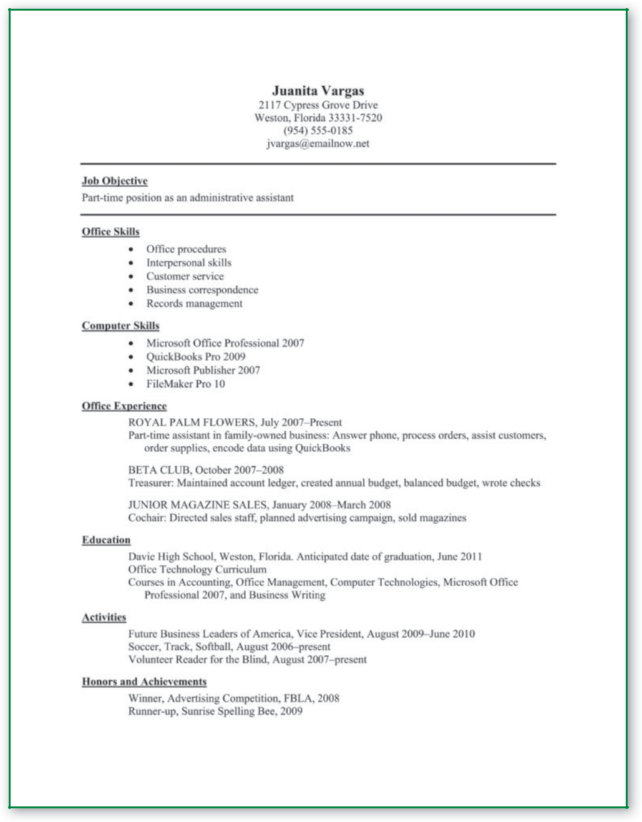

**Figure 11.1** Functional Resume

On the other hand, if the company does not have the same program you used to create the resume or if you are not sure about the program your employer uses, you need to explore other options.

***ASCII Text File***

One option is to send the document as part of the e-mail message. In this case, the employer receives the resume, but it may look jumbled with strange characters when the employer opens the e-mail.

**260 |** Chapter 11

To prevent the resume from looking jumbled, key the resume as an ASCII (American Standard Code for Information Interchange, pronounced *ask-ee*) text file. A **text file** can be opened regardless of the word processing program used. Most word processing programs allow you to save a document as a text (.txt) file, often referred to as a plain text file because of its simple,



plain appearance. The disadvantage of a text file is the loss of formatting in a carefully designed print resume.

For instance, a resume written using an older version of WordPerfect® but saved as a text file should open on a personal computer that uses a current version of Microsoft® Word. Using the text file, you ensure that anyone can open your file. In addition, you can format to a limited degree by using the following suggestions:

Use plain fonts (for example, large, open, “no tails” fonts such as Arial or Calibri) or consider Courier, a fixed font with each character taking up the same amount of space.

Use 10- to 14-point font size.

Use one column, flush with the left margin; do not use side headings or tables.

Use capital letters for heading titles and other important information.

Avoid boldface, italics, underlining, and other characters not on the keyboard.

**COMMUNICATION TECHNOLOGIES**



Many people looking for a job use social networking sites to connect with friends and professionals who might assist in the job hunt. One website, LinkedIn, helps people stay in touch with other professionals. You can create a profi le that highlights your skills the way a resume does, and you can search for jobs. Employers can use LinkedIn to view an applicant’s qualifi cations. The site also provides a way to get to know other people in your area of expertise while you are employed. You need to use good judgment about what you post on the site: do not divulge inappropriate personal or incriminating information—including photos and links.

**Think Critically**

Why is it important to use good judgment with regard to the information you post on a site such as LinkedIn?

Use the space bar instead of tab keys.

Use asterisks, dashes, or hyphens instead of regular bullets. Use wide margins set for 60 characters (1" left, 2.5" right).

Use commas to indicate small breaks, semicolons to indicate breaks in a longer list, colons to set up a list, and periods to end sections.

Figure 11.2 on the next page shows Barbara’s chronological resume formatted as an ASCII text file.

***Scannable Resume***



**Scannable resumes** are mailed as a print document, sent as an e-mail, orposted online to be scanned electronically for **keywords,** significant words that are included in the job announcement. A keyword search compares qualifications on the resume to qualifications the employer needs and determines whether the resume has enough matches to warrant a closer reading. If you are unsure whether a potential employer can read your word processing program, send the file as a text file. If you are confident that the employer will be able to read your word processing program, submit your resume as a word processing document and format your resume for an optical scanner.



Employment Communication **| 261**

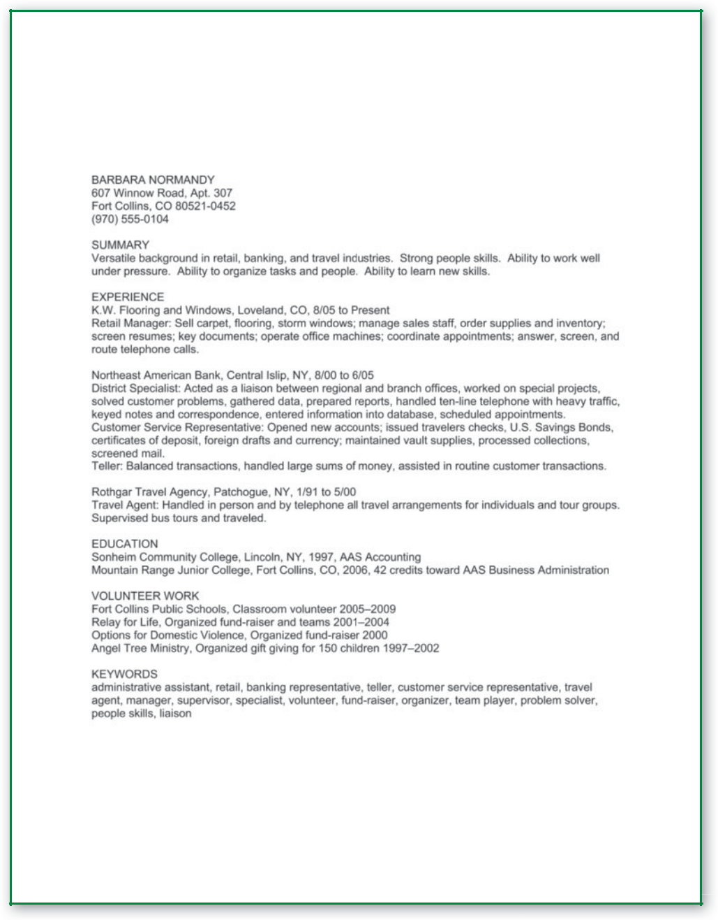

**Figure 11.2** Electronic Resume as ACCII Text File

Use the suggestions for formatting an ASCII text resume with these differences:

You may use boldfacing, but avoid italics and underlining. If you print the resume, use dark black ink on white paper.

If you mail the resume, do not staple or fold pages and use a large envelope so the resume lies flat.

***Online Resume***



An **online resume** is posted on a website. Typically, it is one you create, one your company or school hosts, or one sponsored by a web-based job-hunting

**262 |** Chapter 11

service such as Monster Career Tools or CareerOneStop. Online job-hunting services provide instructions for posting web-based resumes.

Another option is to design your own website from which you post your resume and set up links to your portfolio, references, or professional organizations. Be aware, however, that employers are not likely to visit your personal website for initial screening. Send your resume—print, e-mail, or scannable—and note that you have a website with additional information.

Many job hunters post their resumes on websites that contain not only their resume, but also links to work samples. These websites are sometimes known as electronic portfolios. Employers can view your resume and work samples quickly and do not need to wait for you to send them. Most word processing software allows you to create such portfolios by converting your text to HTML, the language used to create web pages.

 **STOP AND THINK**

Describe the different ways to send an electronic resume. Under what circumstances would you convert a resume to a text file?



**COMPOSING RESUMES**

After you have analyzed your audience and assessed your strengths as an employee, you are ready to compose the parts of your resume. Writing a resume means working through drafts until you have written a professional document with *no errors.*

**Word Choice**

When writing a resume, you want to present information in as few words as possible. The word choice in a resume may be unlike anything you have written before. A resume has its own grammar rules: Sentences and paragraphs are not used because they take too long to read. Instead, resumes are written in fragments, lists, descriptive phrases, and verbs. Resume language is both general and specific, with carefully chosen details.

***Nouns or Nouns* + *Descriptive Phrases***

For naming *Activities, Honors, Achievements,* and *Awards,* use a list of nouns or nouns+descriptive phrases.

**ACTIVITIES:** Key Club treasurer, Girl Scout leader, member Lions Club **AFFILIATIONS:** Key Club, Girl Scouts, Lions Club **SKILLS:**

Knowledge of both Windows and Macintosh environments

Ability to program in a variety of languages, including Lotus Notes, C11, and Java

Experience installing and configuring networks

Warm Up

Have you ever written a perfect paper—an essay, a letter, a short report? Is it possible to write something with no errors? Explain.

Employment Communication **| 263**

**Communication**

**Dilemma**

Grant, age 28, spent two years in the state penitentiary for shoplifting when he was 19 years old. Since that time, he attended classes, obtaining an associate degree in accounting, and spent three years in the U.S. Army. He now has a family and is an involved and respected member of his community.

Grant is applying for a job with D & J Accounting. The application asks if he has ever been convicted of a crime. Since his shoplifting offense, Grant has been a law-abiding citizen.

**Think Critically**

What are the possible consequences if Grant does not reveal the shoplifting incident? What are the possible consequences if he does? What should he do?

***Verb* + *What***

*Verb*+*what* is a quick, effective phrase to describe skills, qualifications, andwork experience. Use action verbs to stress what you can do for an employer. Performance is more impressive than qualifications. The greater the variety of verbs, the more dynamic and effective the resume. Add details to the phrase to show more specific information.

Make sure the lists are consistent in tense: present tense for jobs you currently hold and past tense for jobs you no longer hold. If you have (or had) a title, include the title before your list of duties followed by a colon. Also organize your list of duties in order of importance.

**Present Tense Verbs Describes Jobs You Currently Hold**

|  |  |  |
| --- | --- | --- |
| encode data | install equipment | wait tables |
| provide child | refurbish | manage office |
| care | equipment | staff |
| **Past Tense Verbs Describes Jobs You No Longer Hold** | | |
| sold | analyzed data | assisted customers |
| merchandise |  |  |
| stocked | filed reports | evaluated |
| groceries |  | procedures |

**Job Titles Before Duties**

Cashier: Operated register, greeted customers, and took orders

Shift Manager: Supervised 15 workers, enforced safety measures, and handled payroll

Table 11.2 shows other action verbs you may want to consider.

**264 |** Chapter 11

|  |  |  |  |
| --- | --- | --- | --- |
| accomplished | coordinated | generated | reduced |
|  |  |  |  |
| achieved | counseled | identified | revised |
|  |  |  |  |
| administered | designed | increased | saved |
|  |  |  |  |
| attained | developed | investigated | solved |
|  |  |  |  |
| budgeted | devised | maintained | streamlined |
|  |  |  |  |
| built | established | mentored | strengthened |
|  |  |  |  |
| calculated | evaluated | organized | taught |
|  |  |  |  |
| completed | formulated | planned | trained |
|  |  |  |  |
| contributed | fulfilled | promoted | wrote |
| **Table 11.2** |  |  |  |

***Specific Language***

Think of your resume as the first piece of evidence a potential employer sees regarding your unique skills. As evidence, it should come with sufficient proof of your credentials and accomplishments. The proof comes in those specific, quantifiable bits of information you choose to use on your resume. What you choose to include in these roughly 160 to 350 words (for a one-page resume) proves your qualifications and tailors your resume to the skills your employer needs.

✓ **Specific Language**

Objective: To work as a loan officer in a local credit union (expresses a particular position in a particular banking institution)

Objective: To work part-time as a historical tour guide for a seventeenth-century governor’s palace (responds specifically to the job announcement)

Ensured compliance with EPA and OSHA regulations (responds to query for experience with EPA and OSHA)

Met all 10 performance standards from 2001–2010 (specifies how many and when)

✗ **Vague Language**

Objective: To work as a

professional in a modern

banking environment

Objective: To obtain a summer

part-time position

Enforced safety regulations

Consistently met performance

standards

***Parallel Structure***

When setting up headings, providing information, or creating lists for resumes, use **parallel structure** (use of the grammatical structure already in place). Parallel structure provides consistency, enabling your reader to anticipate your structure.



This means if you begin your employment history with a job title, you list the job title first with every job. If you begin your employment history with the name of the company and the job title second, you list the company name first and the job title second for each job.

Employment Communication **| 265**

Descriptions also should be written in parallel structure.

✓ **Parallel**

Answered calls from field

technicians, created service

bulletins, analyzed warranty

claims, authorized warranty

repairs and modifications,

communicated with design

engineers.

✗ **Nonparallel**

I answered calls from field technicians. Was responsible for service bulletins. Duties included warranty claims analysis and warranty authorization numbers for specific repairs and modifications. Close communication with design engineers is ongoing.

Complete the activity *Finding* *Famous Parallel Statements* available at www.cengage. com/school/bcomm/techwtg. Click the link for Chapter 11; then click Data Files.

**266 |** Chapter 11

**Keywords for Scannable Resumes**

When selecting keywords for a scannable resume, the rules of resume writing change. The print resume relies on verbs to demonstrate skills performed. The scannable resume, on the other hand, relies on nouns that list skills, qualifications, and job titles in a separate heading, *Keywords*. Following are some examples of keywords.

**Skills:** C11programming, graphic design, marketing, statistical analysis,training, database management, communication, problem solving, management, organization, attention to detail

**Job titles:** Computer specialist, manager, supervisor, director, administrativeassistant, chair, facilitator, nurse’s aid, machinist, research assistant

**Qualifications:** Membership in professional organizations, licenses,certifications, degrees, awards

Using several synonyms for one word increases the chances that your keywords will match those of your employer. For example, because the words *hair stylist* and *cosmetologist* are synonyms, you should include both terms when your resume will be scanned. The scanning programs are very literal, though. For example, if the company asks for experience with Microsoft Office Suite, do not write “proficient in Word, Excel, and PowerPoint.” Those terms may not match.

A machine can scan a three-page resume as quickly as a one-page resume. Thus, when in doubt, include more rather than less information when preparing a scannable resume. Print resumes save time for the reader by restricting length and using concise wording. Scannable resumes are thorough.

**Punctuation**

Because resumes do not contain complete sentences, applying traditional punctuation rules is difficult. If one piece of information ends naturally on a single line, you may choose not to put an end mark there. For other marks of punctuation:

Use periods to break up large blocks of text or to indicate a change in information.

Use colons to introduce lists.

Use commas to separate simple lists of three or more items.

Use semicolons to separate complex lists (lists that already contain commas) of three or more items.

Refer to the models in this chapter to see how the resumes are punctuated. Whatever system you adopt, use consistent punctuation throughout your resume.

 **STOP AND THINK**

What is the hardest part of writing a resume? Why? How does the wording of an essay differ from that of a resume? How does a traditional print resume differ from a scannable resume? What are the advantages of an electronic resume?



**COMPOSING EMPLOYMENT LETTERS**

Employment letters give you another opportunity to present your skills. Unlike the resume, these letters are written in traditional paragraphs and complete sentences, also showing the employer how well you write. Three types of employment letters are (1) cover letters to accompany the resume and to highlight the applicant’s strengths; (2) follow-up letters to thank the employer for the interview; (3) and in some cases, resignation letters to announce a person’s decision to leave a company. On occasion, e-mail correspondence takes the place of an employment letter.

**Cover Letter**

A cover letter is a sales letter. It is a persuasive letter that sells you as the product or service. As stated in Chapter 5, sales letters are composed of the hook, the sell, and the motivation to action. A cover letter is composed of an opening (an attention-getter or a hook), a summary of qualifications (the proof or sell), and a request for an interview (motivation to action).

***Opening***

The first paragraph should grab the reader’s attention by:

1. Stating your interest in the job.
2. Describing your qualifications in a way that sets you apart from other applicants.
3. Explaining how you found out about the job.
4. Quickly summarizing your major qualifications for the job.



Most cover letters are **solicited**; that is, they are requested or advertised.

With solicited positions, refer to the advertisement in the opening sentence.



Sometimes, however, you may submit an **unsolicited letter**. In this case, you are looking for employment with an organization that has not solicited or advertised a vacancy. Not all companies advertise their jobs, and you do not know whether there is an opening unless you ask. Your skills may be in such demand that a company creates a position for you. Writing an opening to an unsolicited letter is more of a challenge; you must generate interest immediately. Name-dropping may stimulate interest, or a dynamic opening can emphasize your advantages.

Warm Up



Look closely at the cover letter in Figure 11.3

(page 270) that Matt wrote to accompany his resume. How is this cover letter like a sales letter?



Employment Communication **| 267**

**Solicited Letter Opening**

**(refers to advertisement in the**

**opening sentence)**

A radiography degree and three

years’ experience at Unity

Systems Health Care qualify

me for the radiography position

you advertised recently on Tri-

Point Hospital’s web page of job

openings.

**Unsolicited Letter Opening (generates interest with name dropping and a unique background)**

Dr. Yu Zeng suggested that I contact you about an opening in your radiology department.

With degrees and certifications in medical sonography, radiography, echocardiography, and computed tomography/magnetic resonance imaging, think how valuable my services would be to a small rural hospital with a limited staff. My bedside manner is impressive, and I am available for employment.

***Summary of Qualifications***

The second and third paragraphs justify your claim that you can work for the company by proving your credentials. The letter is not meant to be a copy of your resume. The letter should emphasize qualifications but not repeat the resume word for word. To provide proof that you can perform the job:

1. Describe your education.
2. Describe appropriate work experience.
3. Describe related skills.
4. Explain some of your abilities that you do not mention in your resume.

If you are a recent graduate, your education paragraph will come immediately after your opening paragraph. It will specify your degree and major course of study. It may include relevant courses, accomplishments, and areas of expertise. If you have been in the work force for several years, your work experience



|  |
| --- |
| sjlocke/iStockphoto.com |

**Focus on**

**Ethics**

Recently, the city manager of a small town was fired because he listed a degree in city planning on his resume that he did not actually have. Being two classes short of a college degree, he decided that that was as good as the degree—except that it was not. It was a lie.

Many people have “skeletons in their closets”: a court conviction, a substance abuse problem, or an unfinished degree. It is true that on paper, someone with a conviction does not look as good as the person with a sterling record. Someone without the proper degree does not look as good as the person with the degree. However, the truth is better than any lie conceived to cover up the “skeleton.” If a person cannot be trusted to complete employment data honestly, then he or she is not a good risk for a company.

The bottom line is this: Falsifying employment data carries serious consequences, such as immediate termination or prosecution. Some events in the distant past may have little bearing on the job hunt and need not be disclosed. However, if you are asked about something, do not lie.

**Think Critically**

What are the consequences for the city manager and the citizens of the town?

will come immediately after the opening paragraph and describe relevant jobs and major work-related accomplishments. In the letter, you also have the opportunity to add information about your character, your work habits, your people skills, and any other information you believe is relevant to the job.

***Request for Interview***

The last paragraph in the cover letter motivates the reader to action by asking for an interview and making it convenient to contact you. Make sure you:

1. Refer to the enclosed resume.
2. Ask for an interview.
3. Tell how and when you can be reached by including your phone number(s) and/or e-mail address.

When composing your cover letter, vary your sentence structure. Although it is easy to begin every sentence with *I* when writing about yourself, try to begin some sentences with other words. For variety, consider beginning sentences with prepositional phrases, introductory clauses, and transitional words.

On the next page, Figure 11.3 shows a cover letter that Matt wrote to Hailey O’Dell, personnel director at Monarch Electronic Industries. Matt’s letter gets his reader’s attention by expressing interest in the job opening and stating his desire to move back to Arkansas. Then Matt uses two paragraphs to tell how his education and work experience make him a good match for Monarch. In the last two paragraphs, Matt reveals special knowledge of and interest in the company and asks for an interview. Note the variety of sentences in Matt’s letter.

Employment Communication **| 269**

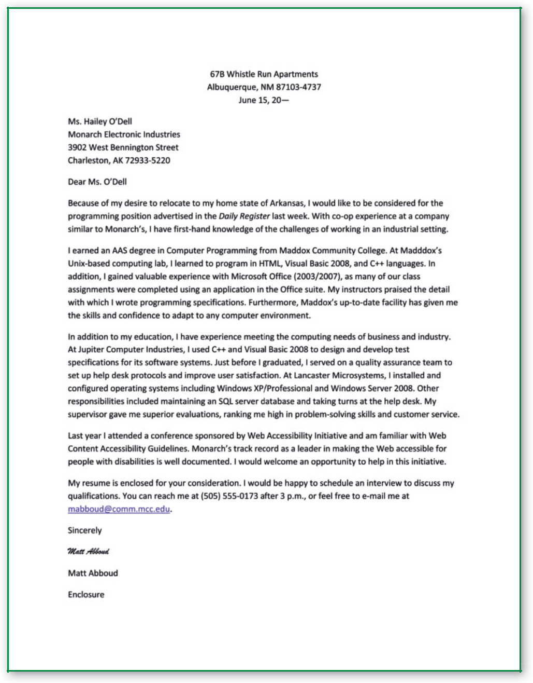

**Figure 11.3** Cover Letter

***E-mail Cover Message***

If you are sending an electronic resume (as an attachment or as part of the e-mail), you need a brief message to accompany the resume. Similar to the cover letter, the e-mail message is briefer.

1. Declare your intention to apply for a particular job.
2. Tell how you are sending the resume and, if applicable, what program you used to encode the resume.
3. Summarize your major qualifications in either a short paragraph or a list.
4. Ask for a meeting or an interview.

**270 |** Chapter 11

**Follow-Up Letter**

You send a follow-up letter, sometimes known as a thank-you letter, immediately after a job interview. The follow-up letter should:

1. Thank the employer for the interview.
2. Remind the employer of something positive that was said or that took place during the interview.
3. Explain why you are the best candidate for the job.
4. Express continuing interest in the job.

Sending a follow-up letter lets prospective employers know that you are still interested and reminds them of your qualifications. It also is permissible to send the follow-up message in an e-mail. With e-mail, make sure you use an appropriate, specific subject line (for example, *Follow-up to Interview*). On the next page, Figure 11.4 shows a follow-up letter that Matt wrote to Ms. O’Dell after his interview.

**Resignation Letter**

Whatever your reason for leaving a job, writing a letter of resignation to inform your current employer of your plans is a professional courtesy.

Your former employer may be contacted for a job reference. A well-written letter of resignation that gives reasonable notice helps ensure goodwill with your current employer. Later, when asked to provide a reference for you, your employer will likely say positive things. To maintain the goodwill of your employer, follow these guidelines:

Find out the company procedure and chain of command. Normally, you write the letter to your immediate supervisor, who would, in turn, pass the letter up the chain of command. In a small work unit made up of people with whom you work closely, use the supervisor’s first name, as you would in memos. In larger work units with a more formal structure, use the supervisor’s last name.

Announce your intention to leave the company. Be clear that you are writing a letter of resignation.

State the last day you will work. Make sure that date provides enough notice according to company policy and your knowledge of company operations.

Use courteous language. Use your manners (*please* and *thank you*) and qualifying words (*might, probably, most likely,* and *seems*) if necessary.

Compliment your employer and the company. Thank your supervisor for any opportunities or special help he or she provided. If you are leaving because you are dissatisfied with the work environment, find something positive to say about the organization, even if it is brief.

Offer to help the company prepare for your absence. You can offer to train your replacement or complete work projects in advance.

Volunteer a reason for leaving only if you feel comfortable doing so. If the employer/employee relationship is strained, you may omit the reason

Employment Communication **| 271**

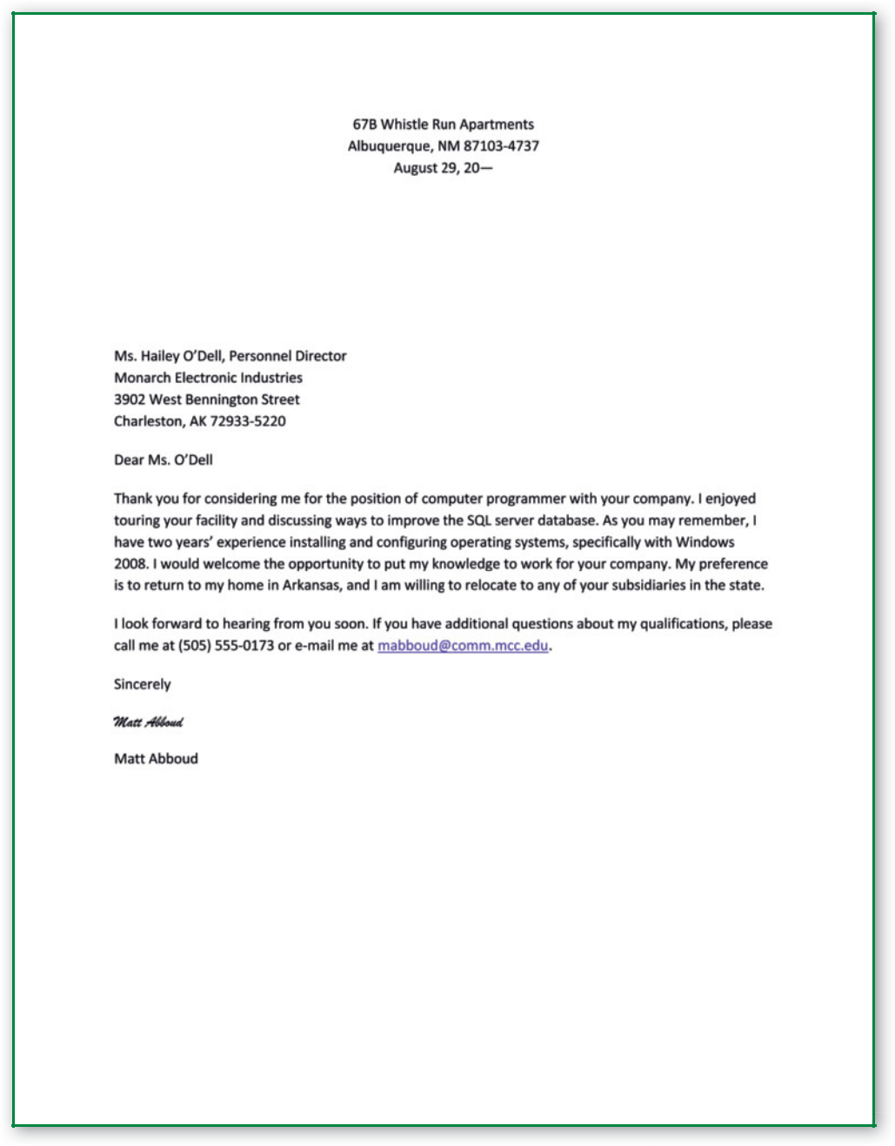

**Figure 11.4** Follow-up Letter

or provide a simple one, such as the desire to pursue other interests. When there is a real problem at work, such as sexual harassment or discrimination, think carefully about explaining the reason.

Close with something positive. Thank your employer once more or say something positive about your upcoming plans.

Montel wrote the letter in Figure 11.5 to Donald Shappel, the director of Charter Disability Services, resigning the position he has held for nine years. Montel has enjoyed a close working relationship with his supervisor.

**272 |** Chapter 11

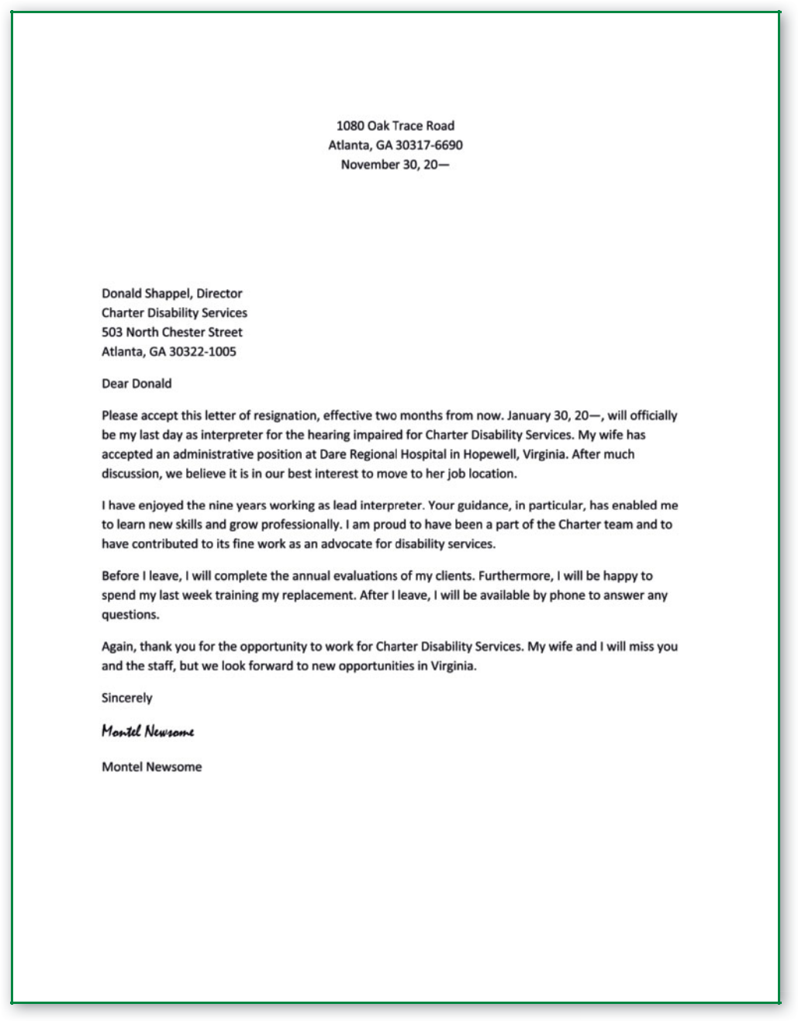

**Figure 11.5** Letter of Resignation

 **STOP AND THINK**

What is the purpose of a cover letter and a follow-up letter? Why should you give as much notice as possible in a letter of resignation?